Bootup issues during upgrade
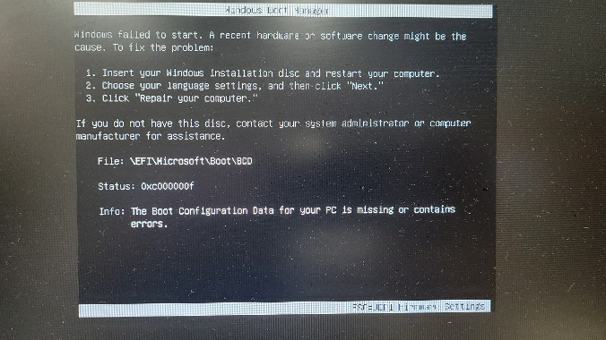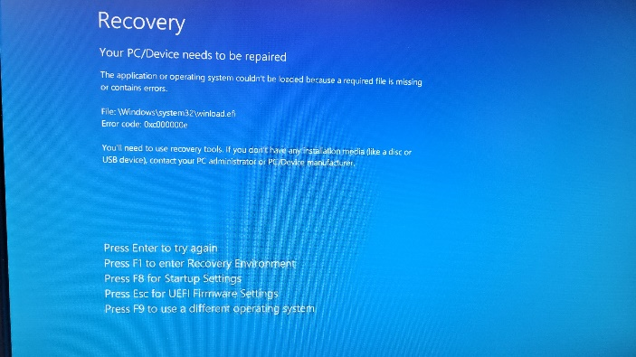

- Hold the delete button or F2 during startup to enter the Bios

- Click on the boot tab and scroll down to UEFI hard disk Drive BBS Properties
If this does not show up, then go through the windows 10 bios setup again and reboot

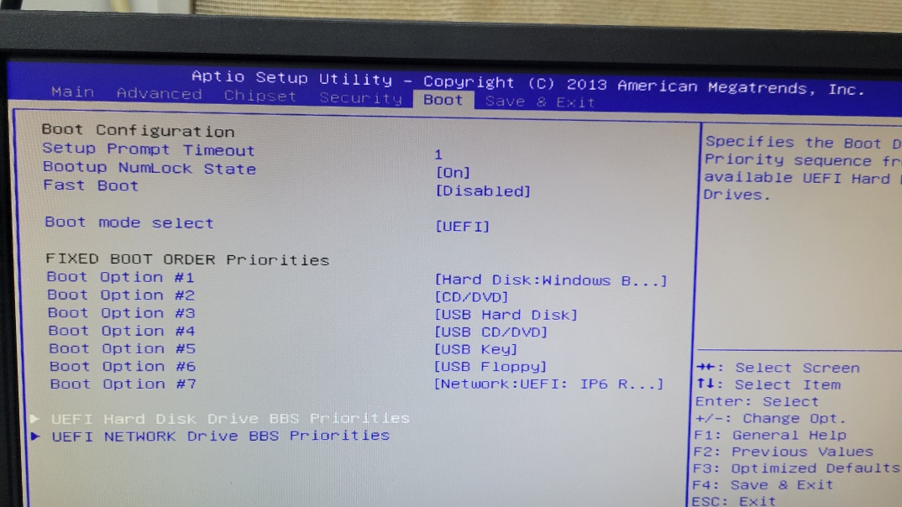

- Click on Boot Option #1 and select the second Windows boot manager

- Click on Boot Option #2 and click Disable

- F4 to save and exit
